**Install docker on EC2 and explore the docker commands (docker images, containers, volumes, network)**

**Install docker on EC2:**

As per our task first, we need to install docker in EC2

**Command:**

Yum install docker

**Screenshot:**

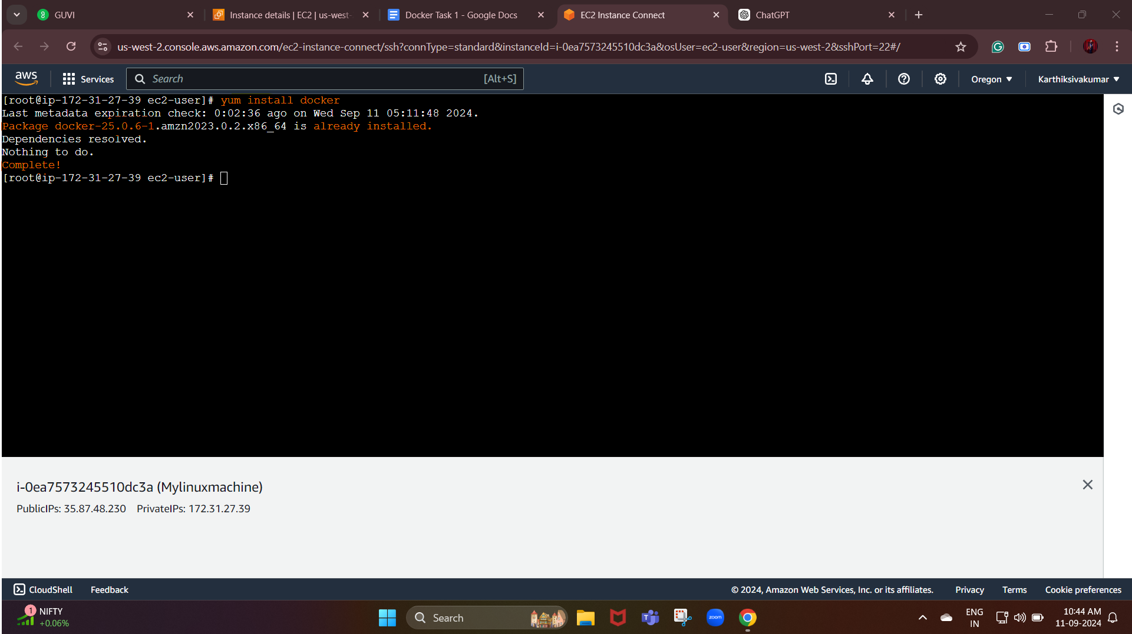

In this case, we have already installed docker in our EC2 instance.

Now, we need to start the docker service in our terminal

Command: sudo service docker start

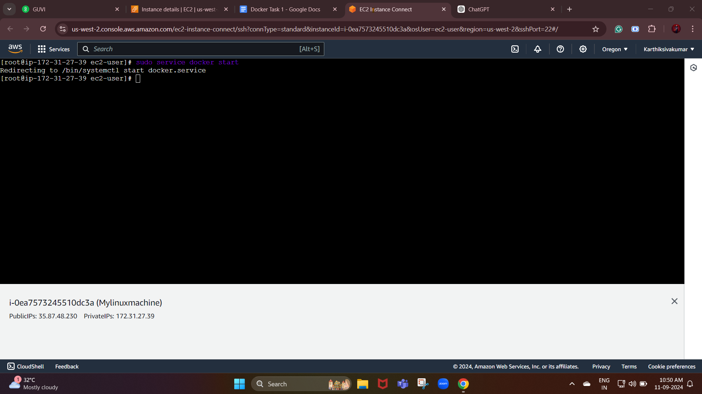

Then, we need to add our user to the docker group (By doing this we don’t need sudo to run docker commands)

Command: sudo usermod -a -G docker ec2-user

Enable docker to start on boot: (By doing this we don’t need to start the docker service each time the machine restarts:

Command: sudo chkconfig docker on

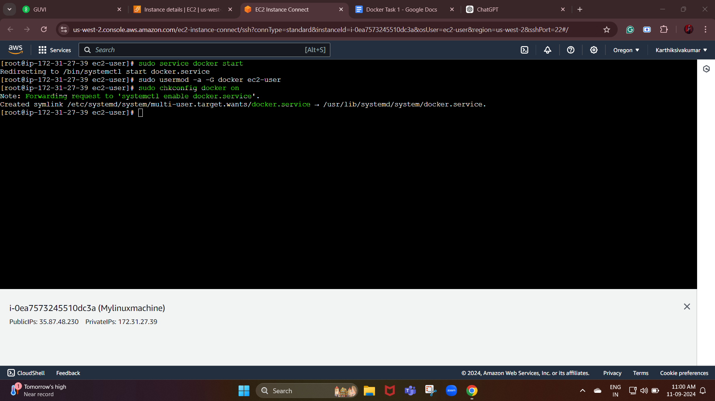

Explore the docker commands:

Docker Image:

List images:

Command: docker images

Pull image from docker hub:

Command: docker pull “image name”

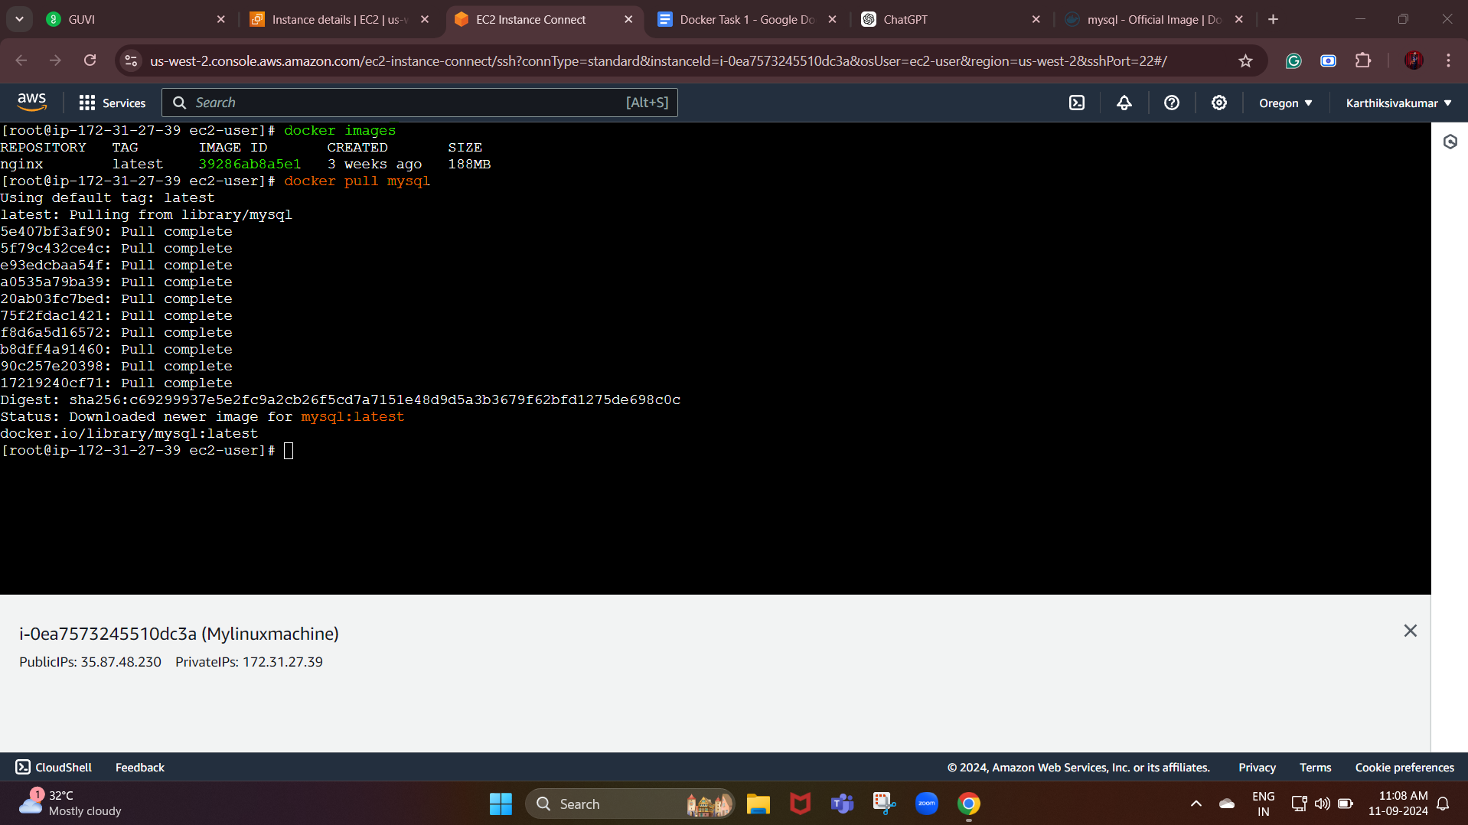

Remove an image:

Command: docker rmi “image id”

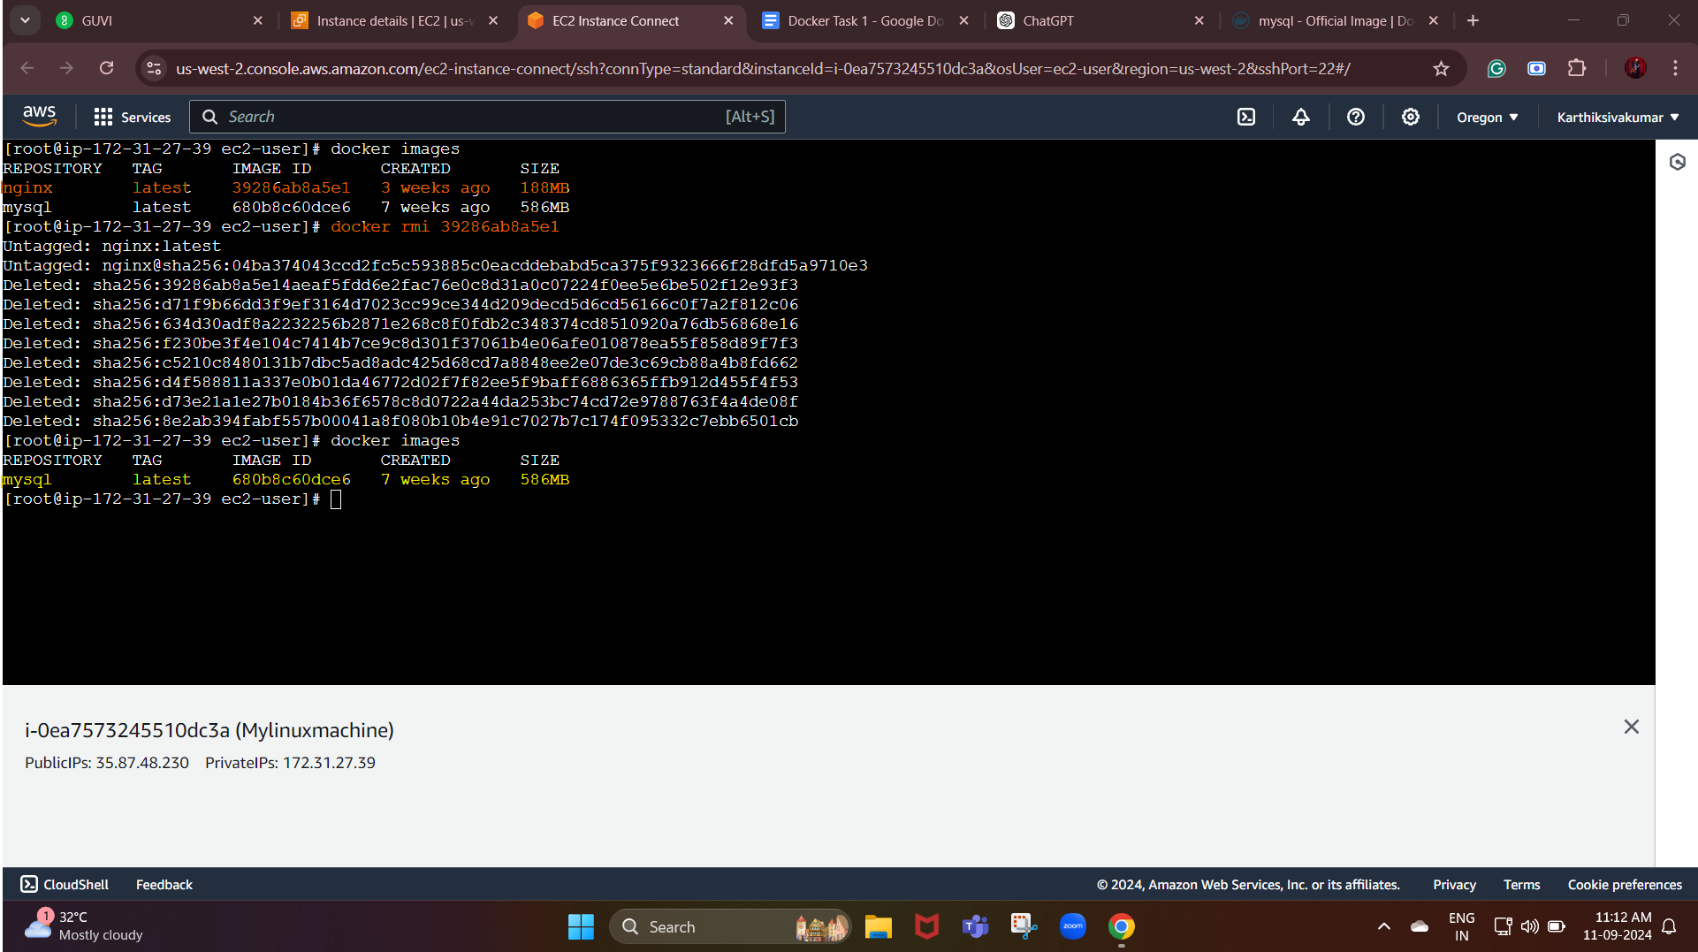

In the above screenshot we can see that one image has been removed by using the remove image command.

Containers:

List running containers:

Start a new container:

Command : docker run -d --name <container_name> <image_name>

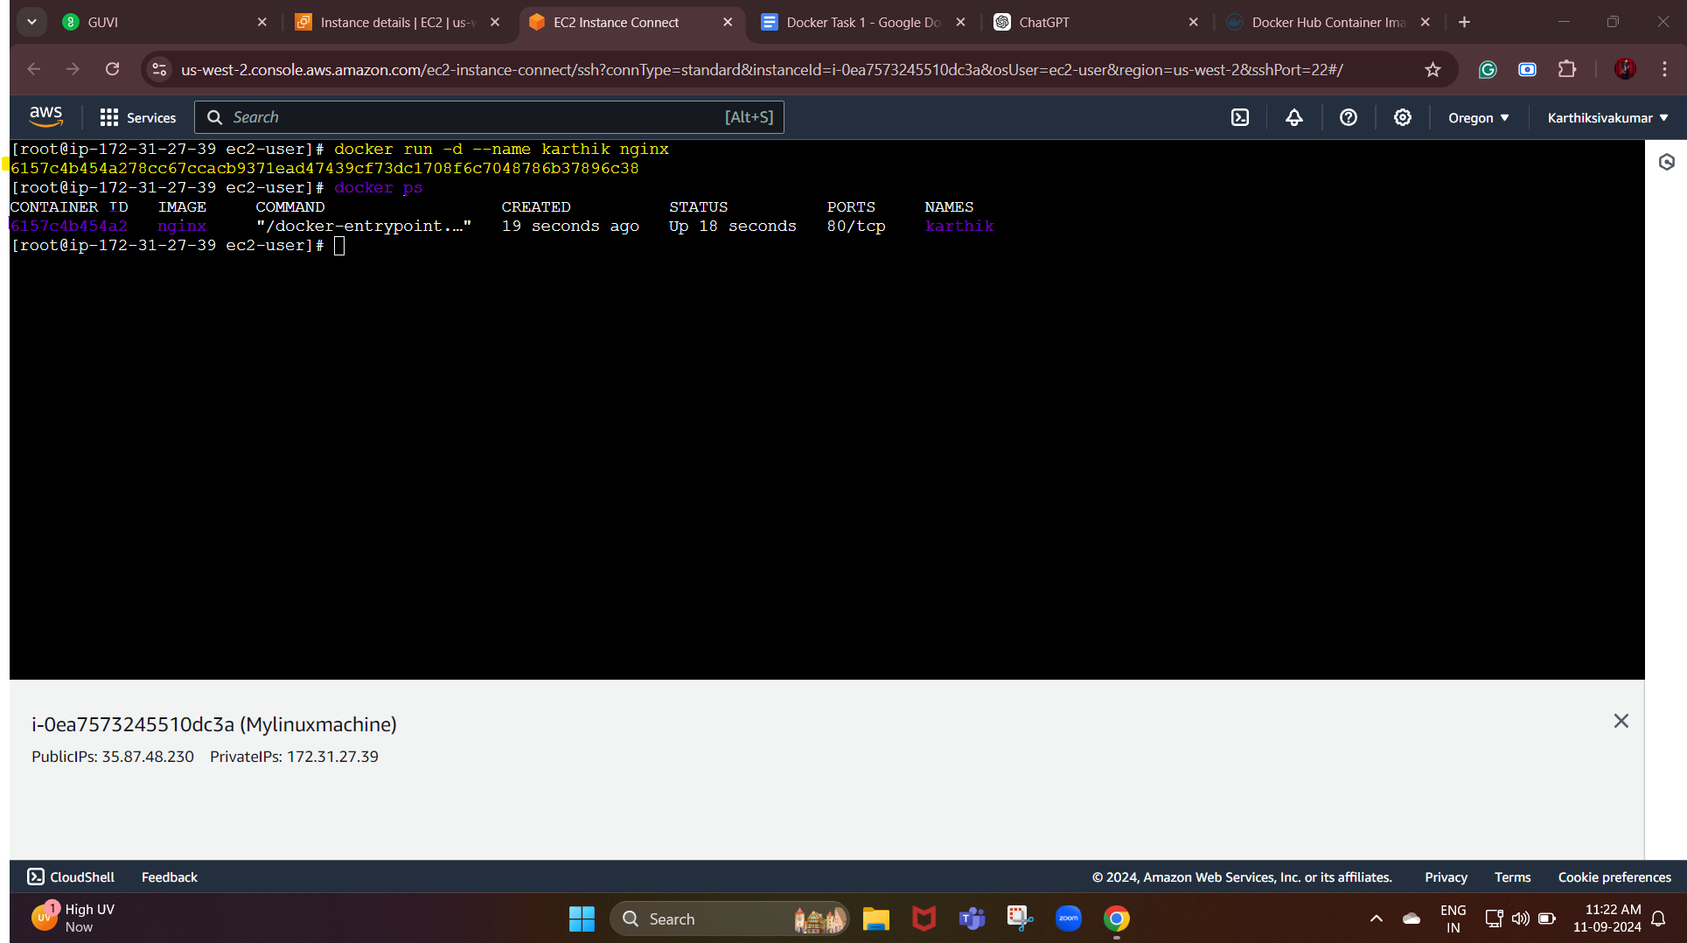

To list running containers:

Command: docker ps

Stop the running container:

Command: docker stop <container name>

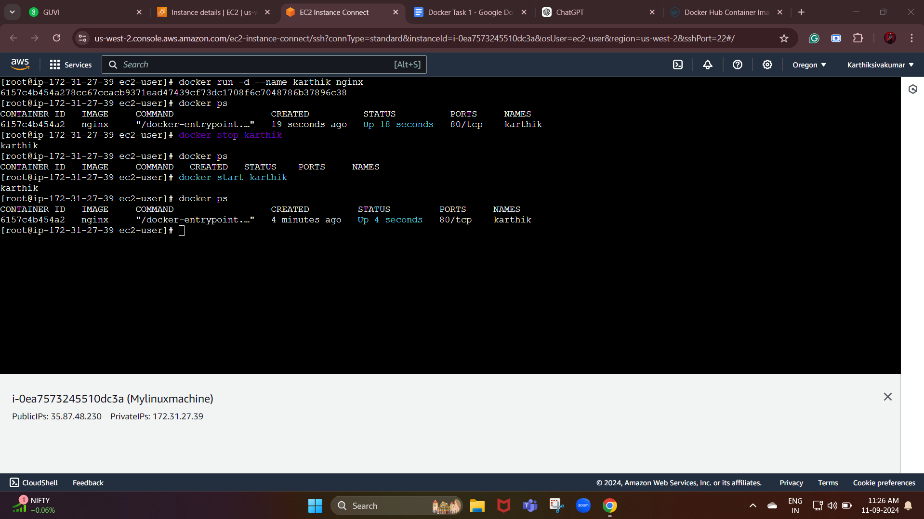

Remove a container:

command: docker rm <container name>

Before removing the container, we need to stop it if it’s running, and then we need to use this command.

Volume:

Creating a volume and list them:

Command:

* docker volume create <volume_name>
* docker volume ls —----------------------> (List volume)

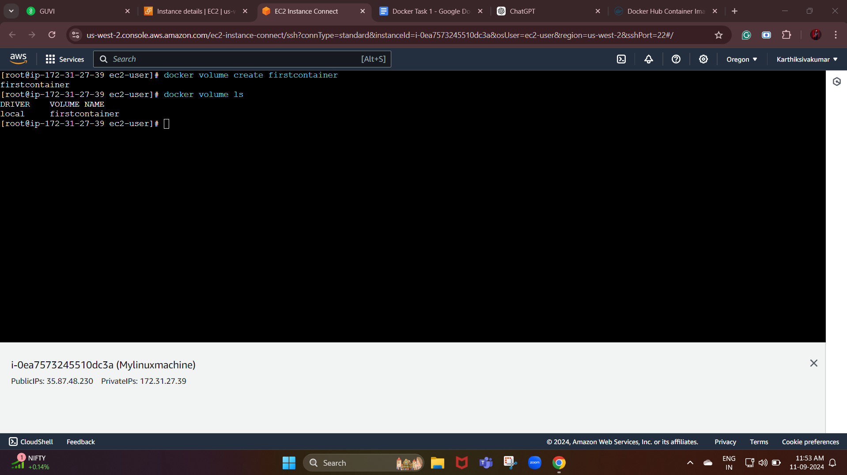

Inspect volume:

docker volume inspect <volume_name>

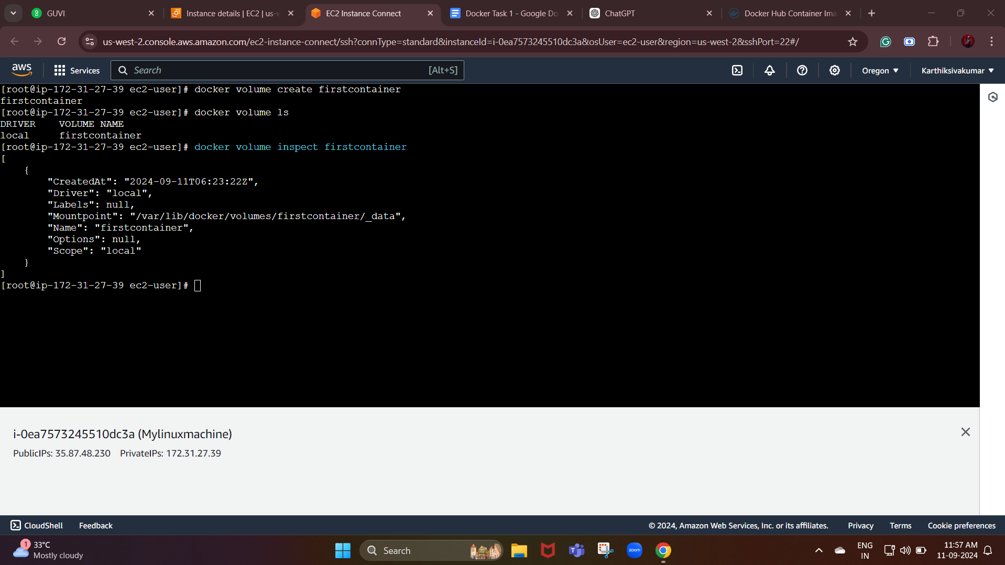

Network:

Create a new network and list them:

Command:

* docker network create <network_name>
* docker network ls

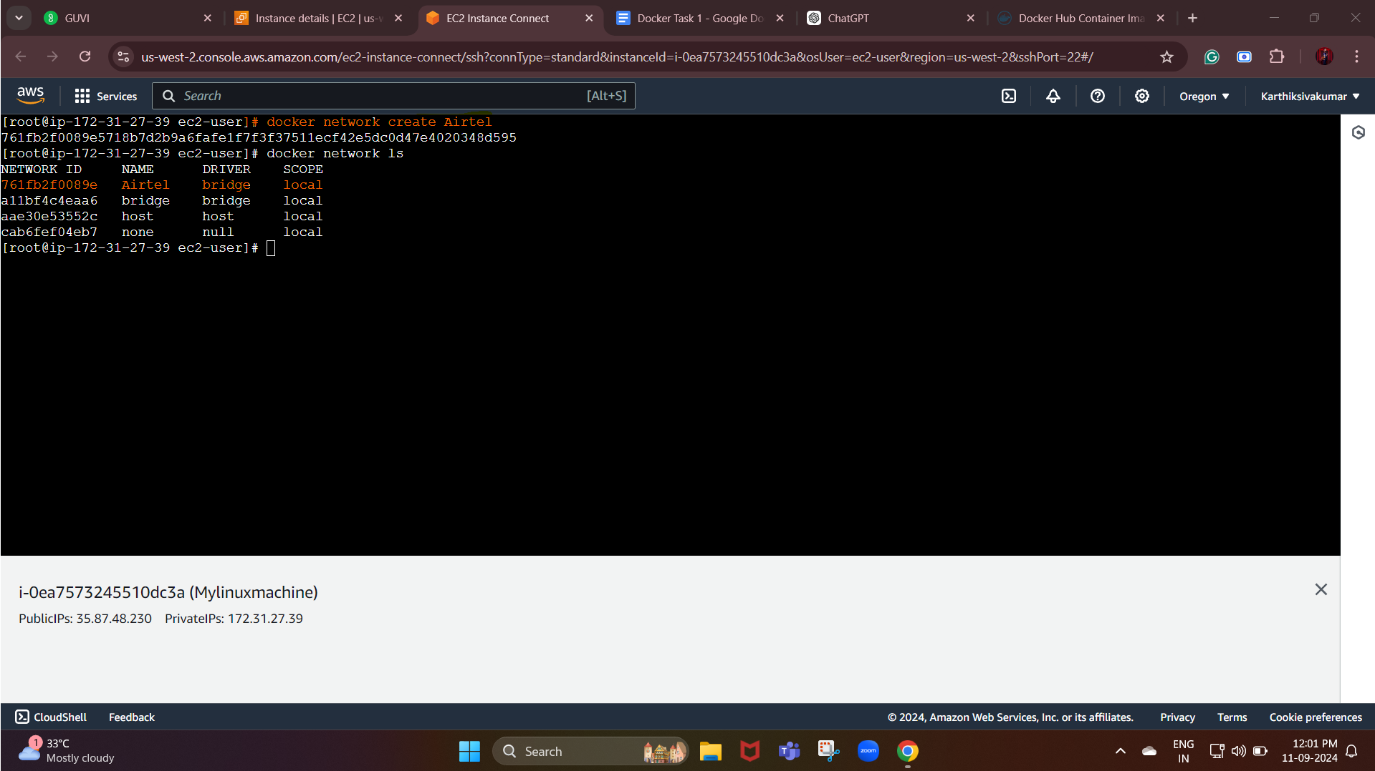

Inspect network:

Command: docker network inspect <network_name>

